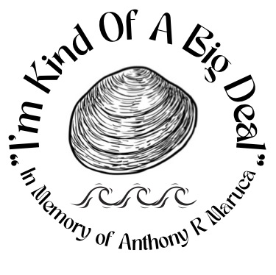
Sponsorship Form
Scholarship payment includes logo on back of t shirt for $250.
Last Name _______________________
First Name ________________________________
Business Name ________________________________
Address ___________________________________________________
City ________________________________
State _______
Zip ___________
Day Phone ________________________________
Email ________________________________
Please make checks payable and send to:
IKOABD
2513 Waters Edge Drive
Toms River, NJ
08753
Please email all company logos in High resolution PDF form to: ikoabd33@gmail.com
All scholarship financial donations due by September 25, 2024
I’m Kind of a big Deal is a New Jersey Non profit Memorial Scholarship fund and is not a 501-c3 organization.

